Climate Bond Summary Sheet: Nordex SE Green Schuldschein
Further information on this Certified Climate Bond is contained in the Verifier’s Report and the Climate Bonds Blog which are available from the Climate Bonds Initiative website.
Nordex SE Green Schuldschein
Issuer | Nordex SE
Jurisdiction | Germany (German Schuldschein)
Value & Currency | Up to 450 million EUR (estimated value until issued)
Issuance Timing & Tenor(s) | Issuance timing to be confirmed. Immediate marketing after Certification.  Tenor to be confirmed.
Type of Bond | German Schuldschein (see below for comparison to corporate bond)
Use of Proceeds | The proposed Schuldschein is to finance the merger of Acciona Wind Power (AWP) and Nordex SE, both exclusive manufacturers of wind turbine hardware. The Issuer, Nordex is a corporation with the sole function of manufacturing, installing and servicing of wind turbine hardware. As verified by DNV GL, the AWP merger decision is designed to consolidate Nordex’s position as a manufacturer of wind turbine hardware globally.  Financing new assets (production, order backlog, intellectual property of AWP) and partly usage for refinancing an existing bond used for expansion of the own rotor blade production.
Standards & Eligibility Criteria | Certified under Climate Bonds Standard v2.0  Sector-Specific Criteria for Wind
Approved Verifier | DNV GL
Reporting & Disclosure | As a stock listed company in the German Prime Standard Segment, Nordex is obliged to report on a quarterly basis. Financial calendar can be found on the Nordex website: http://www.nordex-online.com/en/investor-relations/financial-schedule.html  Quarterly Reports will be made public. Annual Report audited by external auditors.
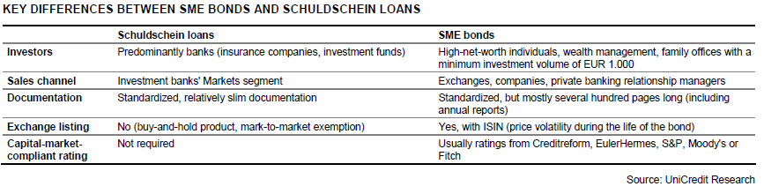  Key Features | This is the first Green Schuldschein to be issued in the German market. Below is background on the structure and features of a German Schuldschein, which has been taken from a 2011 UniCredit research report.  - For issuers, the advantages of Schuldschein loans include: quickness and efficiency, low issuance costs, discretion and confidentiality, flexibility, procurement of long-term unsecured funding and the diversification of the lender base by accessing the large German buy-and-hold investor community.  - The investor base for Schuldschein loans consists of banks, insurance companies and investment funds, principally from Germany and Austria, but also from a number of other European and Asian countries.  - For investors, the way in which Schuldschein loans are treated under IFRS is one of their attractions. These instruments are treated as loans and therefore do not have to be marked to market, which makes them particularly interesting for buy-and-hold investors.  - In addition, investors can enhance their credit portfolio diversification by investing in new names from the upper levels of the German SME segment or non- German issuers.

